**pu**

Funded by the European Union. Views and opinions expressed are however those of the author(s) only and do not necessarily reflect those of the European Union or the European Education and Culture Executive Agency (EACEA). Neither the European Union nor EACEA can be held responsible for them.

**Report WP2-A3**

Report on the analysis of available online tools and applications applicable for the proposed innovative textbook platform

**Result:** Report on the analysis of available online tools and applications applicable for the proposed innovative textbook platform

**Related to:** WP2-A3: Analysis of available tools and applications for online education

**Statement of originality**

This deliverable contains original unpublished work, except where clearly indicated otherwise. Acknowledgement of previously published material and of the work of others has been made through appropriate citation, quotation, or both.

**Disclaimer**

This report contains material which is the copyright of TET Consortium Parties. All TET Consortium Parties have agreed that the content of the report is licensed under a Creative Commons Attribution Non-Commercial Share Alike 4.0 International License. TET Consortium Parties does not warrant that the information contained in the Deliverable is capable of use, or that use of the information is free from risk, and accept no liability for loss or damage suffered by any person or any entity using the information.

**Copyright notice**

© 2022-2025 Consortium Parties

**Note**

For anyone interested in having more information about the project, please see the website at: www

https://licensebuttons.net/l/by-nc/3.0/88x31.png This publication is licensed under a [Creative Commons Attribution-NonCommercial 4.0 International Public License](https://creativecommons.org/licenses/by-nc/4.0/legalcode) (CC BY-NC 4.0).

Table of contents

1. Introduction 3

2. Definitions and abbreviations 3

3. Work methodology 4

4. Results of the survey 4

Summary 4

References 5

# Introduction

The report presents the results of a survey conducted as part of the WP2 activity in the project. The purpose of the survey is to find out users' expectations of working with The Evolving Textbook.

# Definitions and abbreviations

# Work methodology

## General overview

The methodology consists of the following steps:

Step 1 - Development of the questionnaires.

Step 2 – Validations of the questionnaires.

Step 3 – Questionnaires approval.

Step 4 – Development of the survey plan.

Step 5 – Collecting the feedbacks

Step 6 – Data analysis

## Development of the questionnaires

The surveys were developed for the TET project by a team from Rzeszow University of Technology. The questionnaires were developed based on the identified functionalities of tools supporting remote teaching, such as Moodle, MS Teams, Miro, Google Classroom, Google Docs, Trello. The first draft of the questionnaire was presented at the project meeting on February 15, 2023. After taking into account the comments of the project team members, 2 draft questionnaires for the teacher and for the student were approved at the next meeting.

## Validation of the questionnaires

Validation of the questionnaire was carried out from 14.03.2023 to 17.03.2023. 1 teacher and 1 student from each of the project partners participated in the validation. Comments were made on minor errors , the surveys were corrected.

## Questionnaires approval

The survey was approved at the project team meeting on................. Teachers and students completed the survey from 20.03.2023 to 10.04.2023.

# Results of the survey

## Total number of questionnaires received

The survey was conducted between 20.03.3023 and 10.04.2023. The total number of questionnaires received from Students was **229** (see Figure 1) and the total number of questionnaires received from Teachers was **116** (see Figure 2).

**Figure 1** – Number of questionnaires received from Students by universities

**Figure 2** – Number of questionnaires received from Teachers by universities

## Teacher questionnaire results

The teacher survey contains 30 questions. The following is the content of the questions and the responses of the survey respondents. with comments.

1 University

**116 teachers** participated in the survey mainly from universities - partners of the project, as shown in Figure 2.

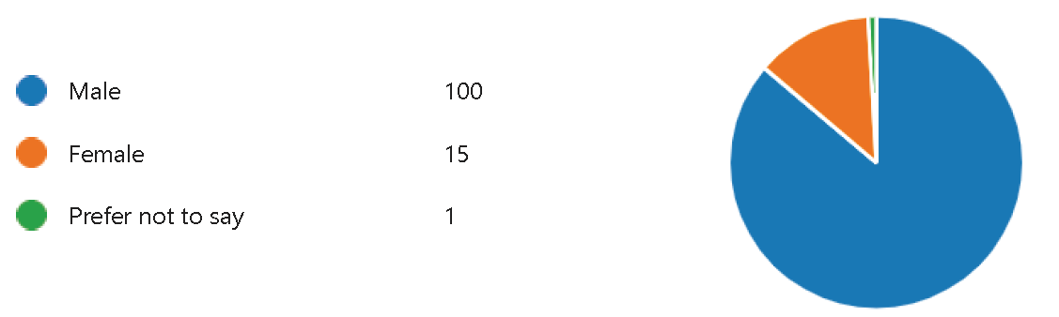2. Gender

**Figure 3** – Gender of respondents

The majority of respondents were declared male gender.

1. 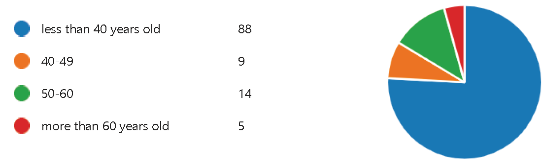Age

**Figure 4** – Age of respondents

About 75% of respondents are under 40 years old. Less than 5% of teachers are over 60 years old.

4. What e-learning platforms / tools do you use?

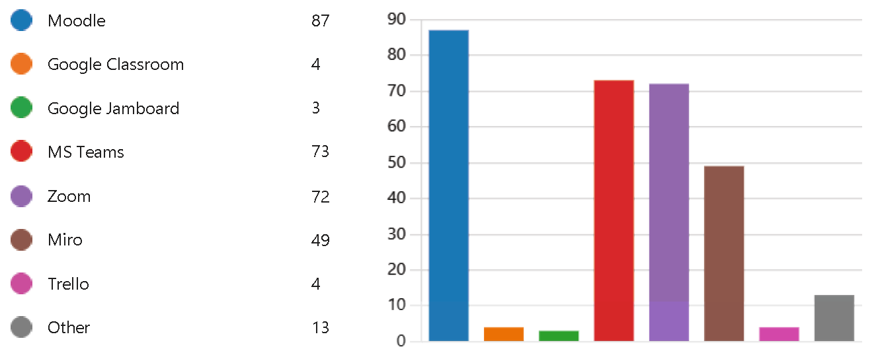

**Figure 5** – E-learning platforms used by teachers

Teachers mostly use **Moodle, MS Teams, Zoom** and Miro in distance learning.

5. What tools supporting e-learning do you use in teaching / learning process?

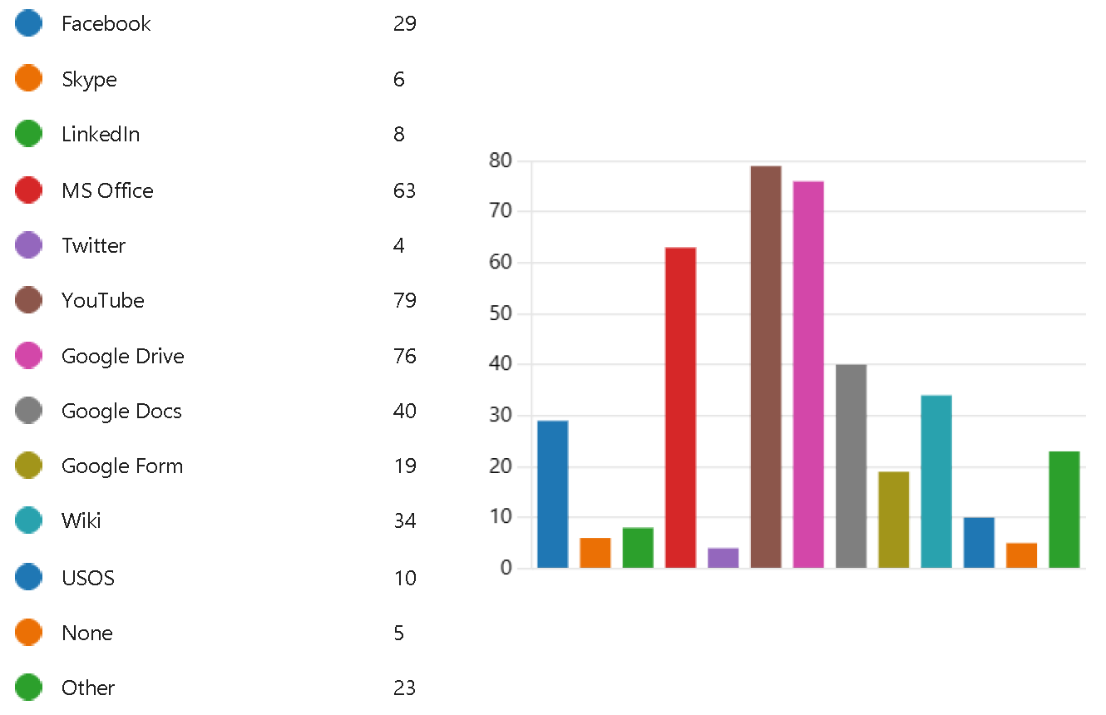

**Figure 6** – Tools supporting e-learning used by teachers

In addition to the e-learning platforms mentioned in question 4, teachers use many tools to support e-learning. Among the most popular are: **YouTube, Google Drive, and MS Office**. Teachers also use Google Docs, Wiki, Facebook, and Google Form.

**6. What are the useful account management functionalities of the e-learning platforms / tools you use?**

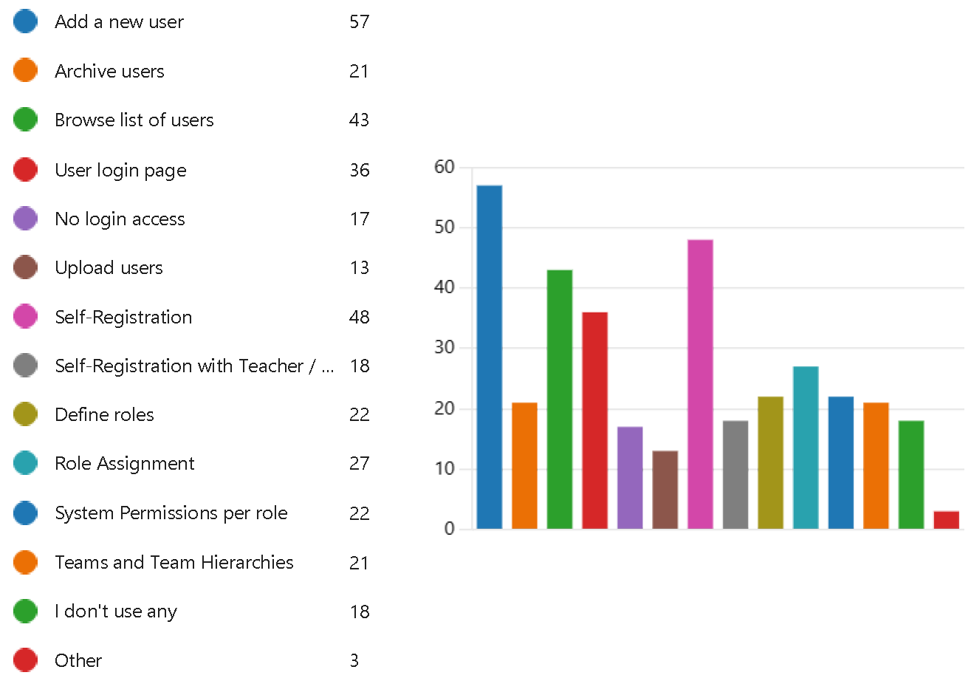

**Figure 7** – Account management functionalities used by teachers

Responses to this question show that teachers make extensive use of account management tools. The most commonly used functionalities include: **adding users, self-registration, role assignment**, user login page.

**7. What account management functionalities do you miss in the e-learning platforms /tools you use?**

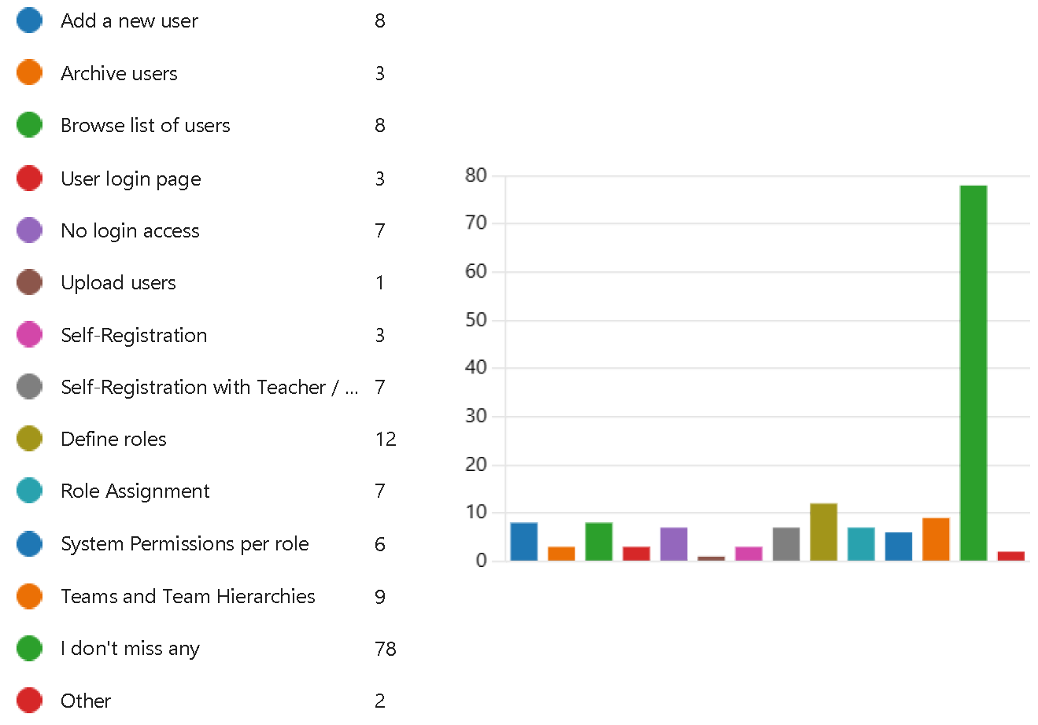

**Figure 8** – Account management functionalities missed by teachers

More than half of the respondents feel no lack of account management functionality. The others miss the functionality to **define roles, teams and team hierarchies**, **system permissions per role**, browse list of users.

**8. What are the useful activity grading functionalities of the e-learning platforms / tools you use?**

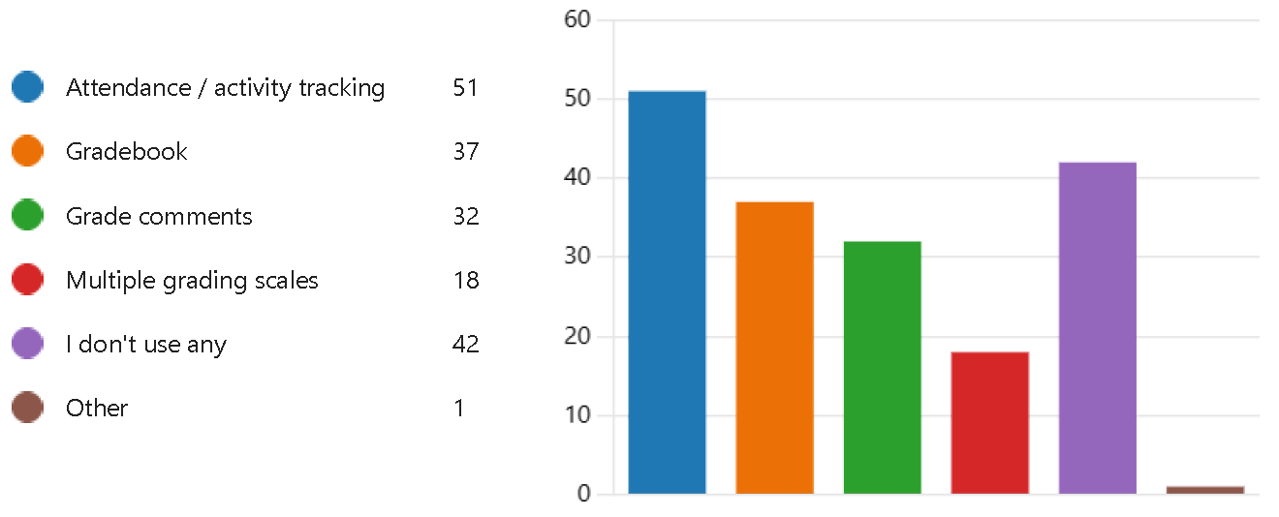

**Figure 9** – Activity grading functionalities used by teachers

Teachers commonly use activity grading functionalities. Most popular are **attendance/activity tracking,** **gradebook** and**grade comments**. Less used functionality is multiple grading scales.

**9. What activity grading functionalities do you miss in the e-learning platforms / tools you use?**

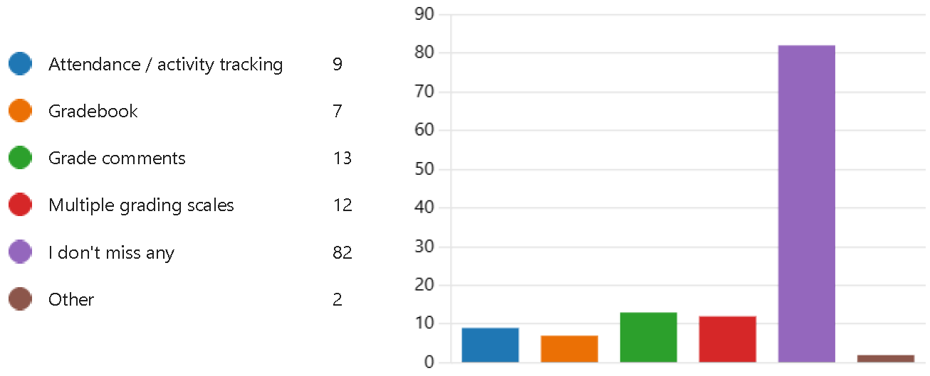

**Figure 10** – Activity grading functionalities mised by teachers

Most important missing functionality are **grade comments** and **multiple grading scales**.

**10. What are the useful certificate management functionalities of the e-learning platforms / tools you use?**

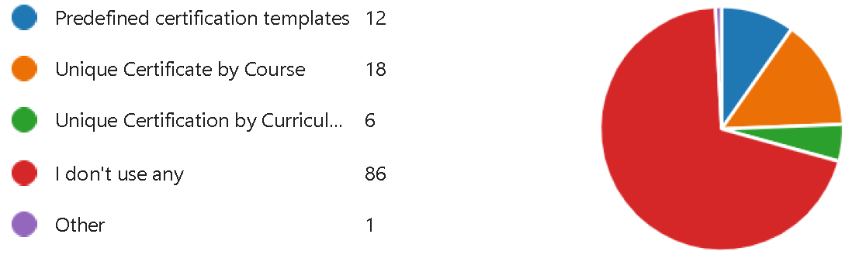

**Figure 11** – Certificate management functionalities used by teachers

About 70% of respondents do not use certificate management. The remaining teachers mainly use unique **certificate by course and predefined certification templates**.

**11. What certificate management functionalities do you miss in the e-learning platforms / tools you use?**

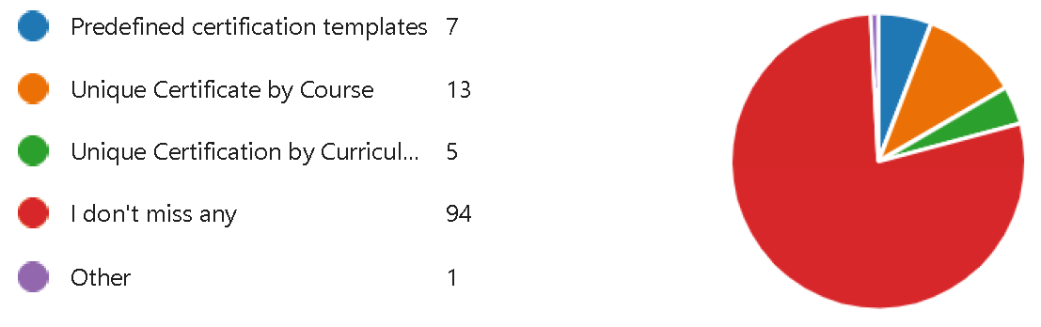

**Figure 12** – Certificate management functionalities missed by teachers

About 80% of teachers do not feel the lack of certificate management functionalities. The others would like to be able to use mainly **unique certificate by course and predefined certification templates**.

**12. What are the useful creation functionalities of the e-learning platforms / tools you use?**

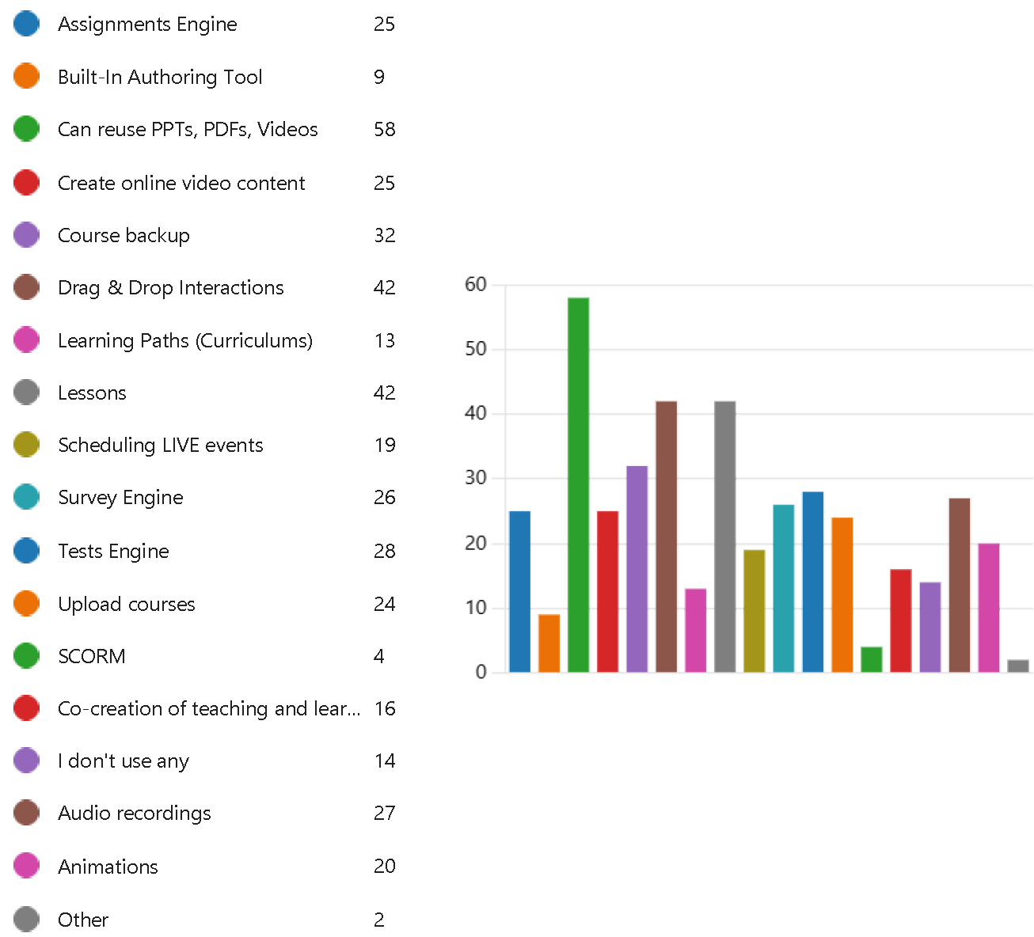

**Figure 13** – Creation functionalities used by teachers

Teachers mostly use the ability to **reuse materials (PPT, PDF, Video), drag & drop interactions, lessons**, course backup, test and survey engine, audio recordings. SCORM format seems to be less important.

**13. What creation functionalities do you miss in the e-learning platforms / tools you use?**

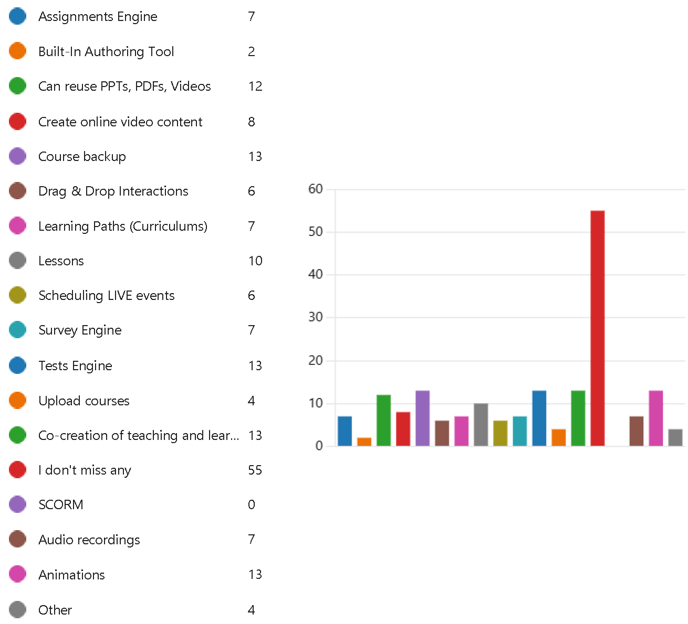

**Figure 14** – Creation functionalities missed by teachers

Teachers most often lack the functionalities connected to creation of teaching and learning: **course backup, animations, test engine and co-creation**.

**14. What are the useful co-creation functionalities of the e-learning platforms / tools you use?**

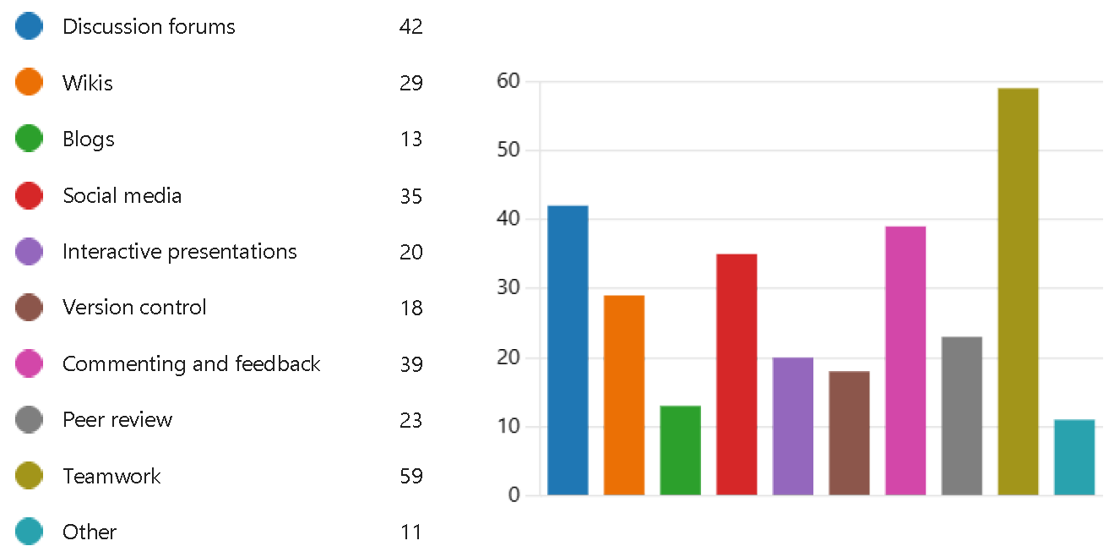

**Figure 15** – Co-creation functionalities used by teachers

Teachers mostly use **teamworking, discussion forums, commenting and feedback**, social media, wikis and peer review.

**15. What co-creation functionalities do you miss in the e-learning platforms / tools you use?**

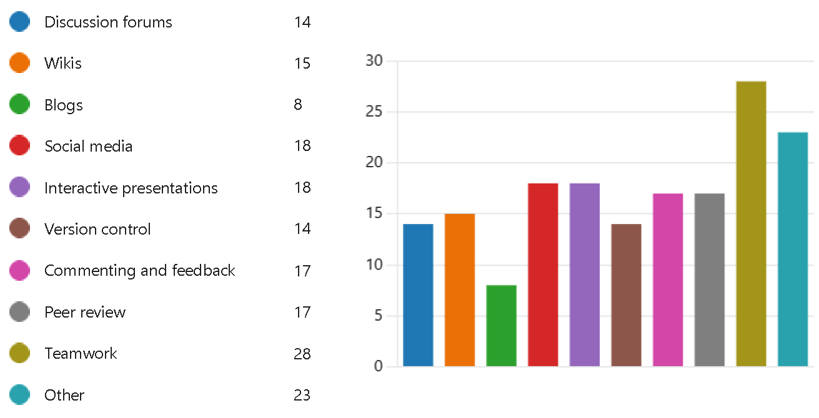

**Figure 16** – Co-creation functionalities missed by teachers

Teachers in co-creation of materials would like to use **teamworking, social media, interactive presentations**, peer review, commenting and feedback, wikis, discussion forums, version control and blogs.

**16. What are the useful communication functionalities of the e-learning platforms / tools you use?**

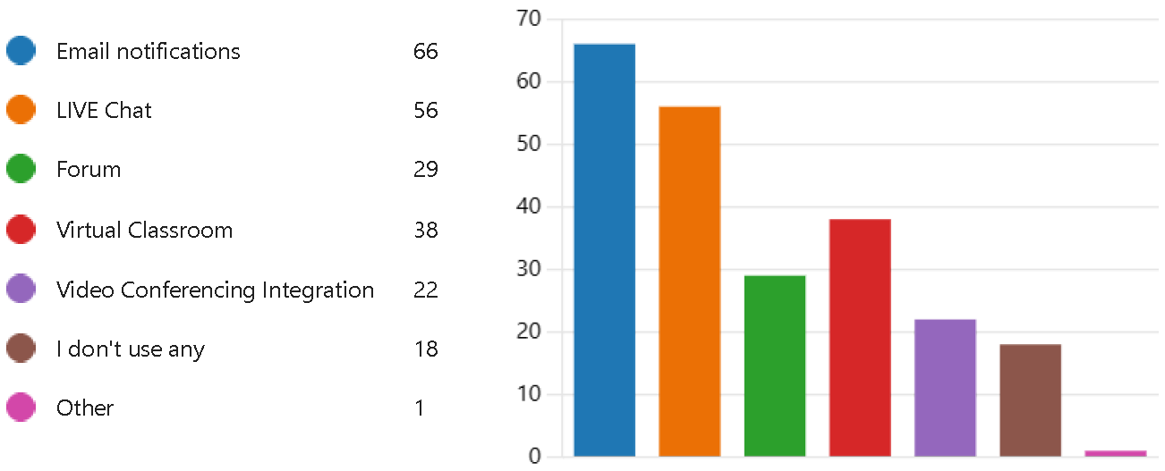

**Figure 17** – Communication functionalities used by teachers

The most usefull communication functionalities for teachers are: **email, chat, virtual classroom**, forum and video conferencing.

**17. What communication functionalities do you miss in the e-learning platforms / tools you use?**

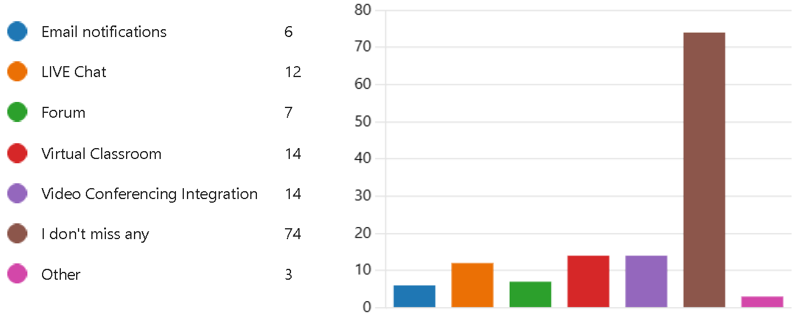

**Figure 18** – Communication functionalities missed by teachers

More than half of the teachers do not feel a lack of communication tools. The others mainly point to the lack of **video conferencing, virtual classroom and live chat**.

**18. What are the useful gamification functionalities of the e-learning platforms / tools you use?**

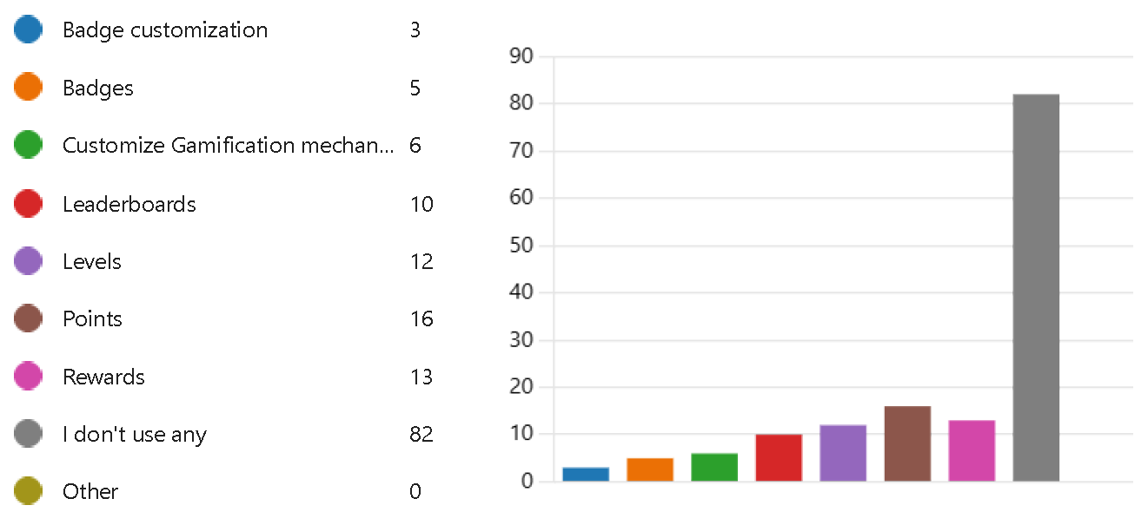

**Figure 19** – Gamification functionalities used by teachers

The vast majority of teachers do not use gamification. There is little use of **points, rewards, levels** and leaderboards.

**19. What gamification functionalities do you miss in the e-learning platforms / tools you use?**

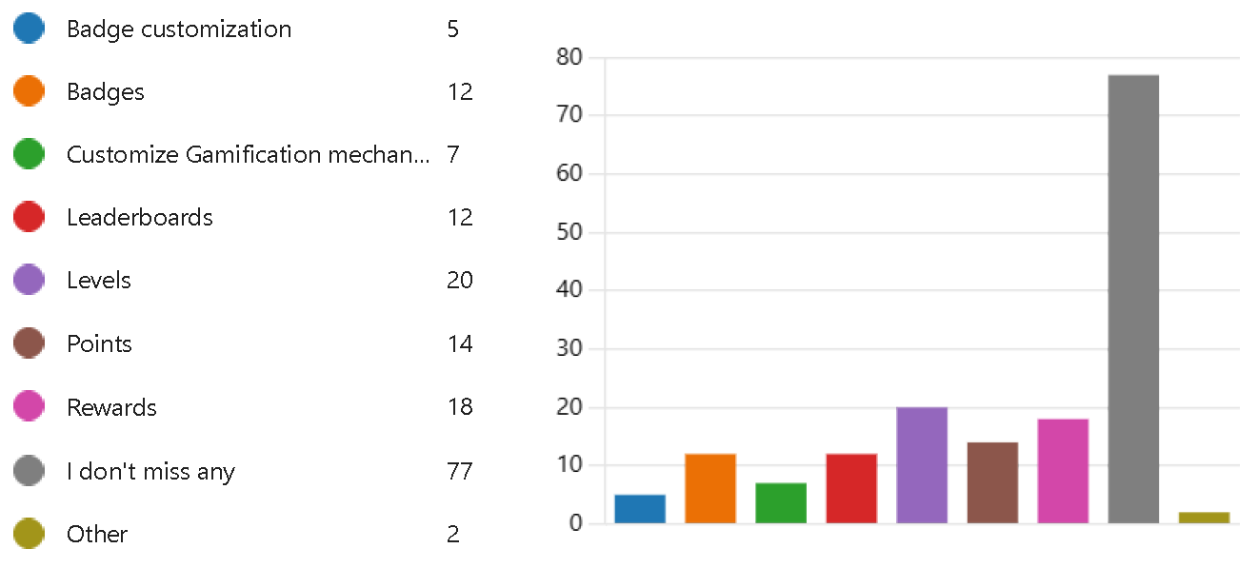

**Figure 20** – Gamification functionalities missed by teachers

Most teachers see no need for gamification. The others would mainly like to use **levels, rewards, points**, badges and leaderboards.

**20. What are the useful learning types functionalities of the e-learning platforms / tools you use?**

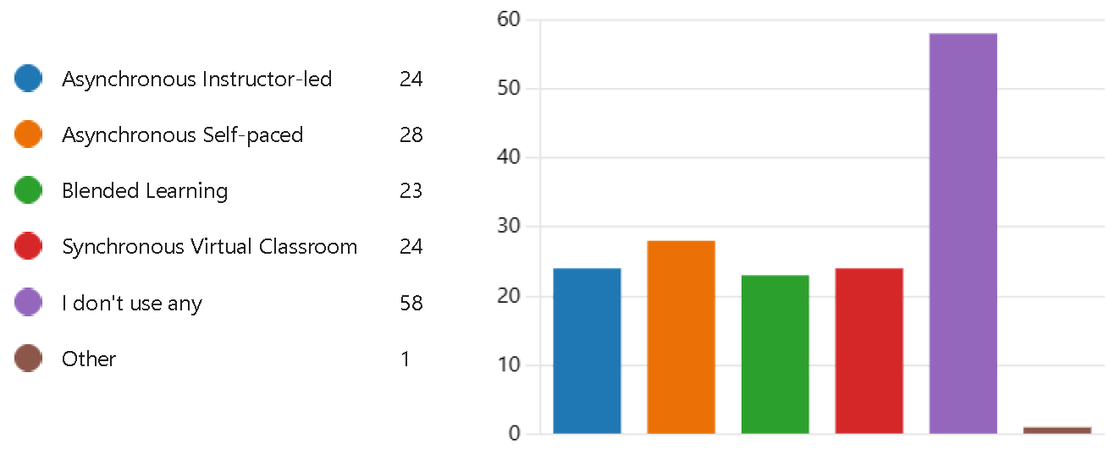

**Figure 21** – Learning types used by teachers

About half of the teachers do not use any of the given types of e-learning. All the types of e-learning given in the question are used at similar levels.

**21. What learning types functionalities do you miss in the e-learning platforms / tools you use?**

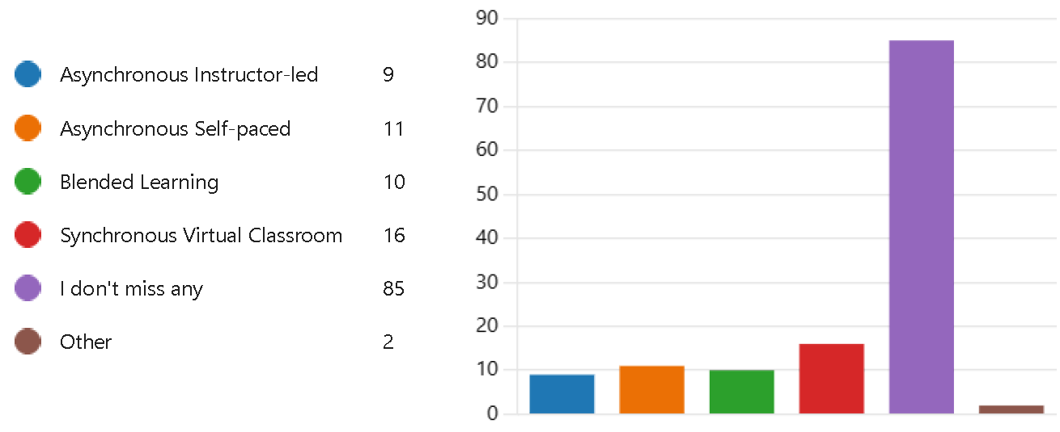

**Figure 22** – Learning types missed by teachers

The majority of teachers do not see the need to use one of the indicated types of e-learning. Among the other responses, synchronous virtual classroom stands out slightly.

**22. What are the useful mobile learning functionalities of the e-learning platforms / tools you use?**

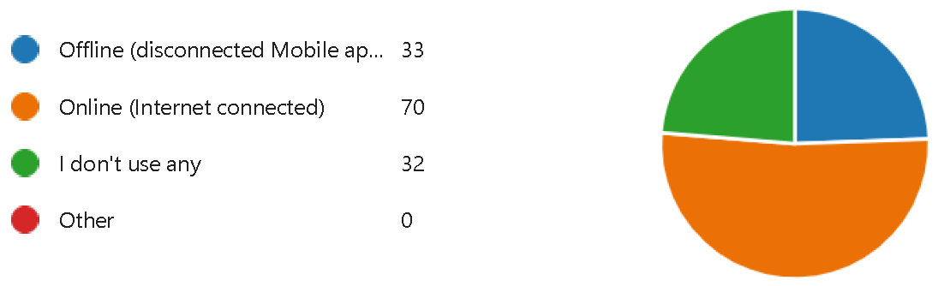

**Figure 23** – Mobile learning functionalities used by teachers

**23. What mobile learning functionalities do you miss in the e-learning platforms / tools you use?**

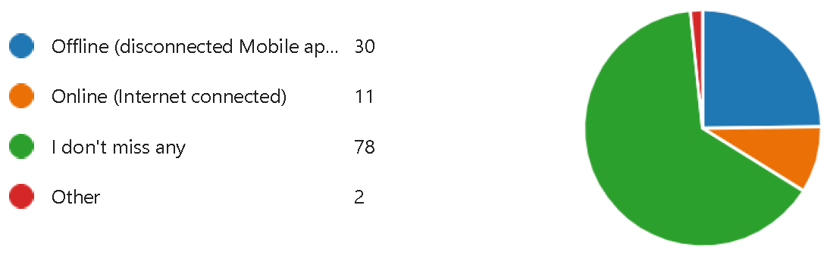

**Figure 24** – Mobile learning functionalities missed by teachers

**24. What are the useful system reports functionalities of the e-learning platforms / tools you use?**

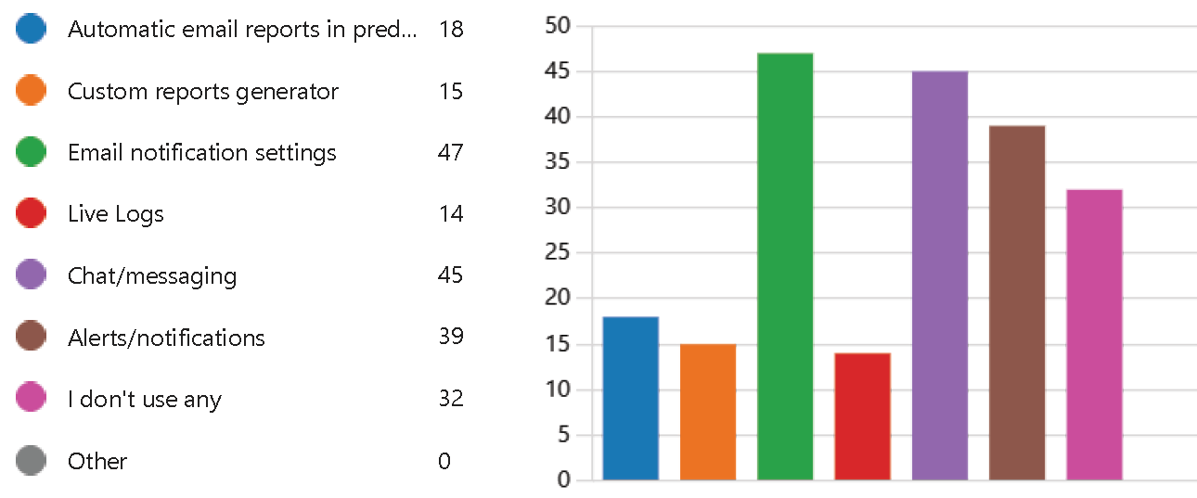

**Figure 25** – System reports functionalities used by teachers

Teachers mainly use **email notifications, chat/messaging and alerts/notifications**.

**25. What system reports functionalities do you miss in the e-learning platforms / tools you use?**

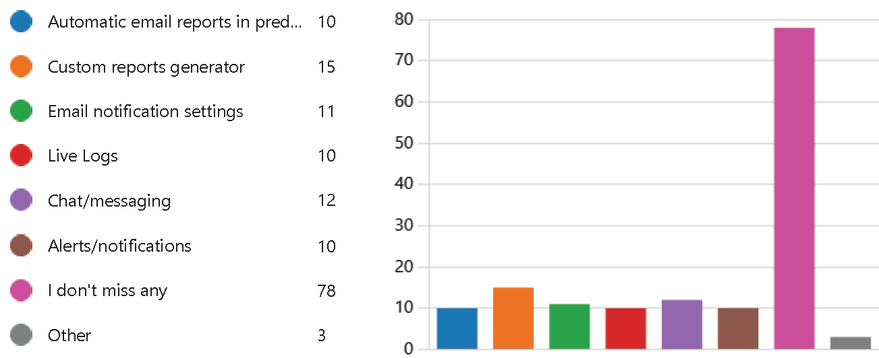

**Figure 26** – System reports functionalities missed by teachers

The vast majority of teachers do not lack report functionalities. Among the expected functionalities, the **custom reports generator** stands out slightly..

**26. What other useful functionalities of the e-learning platforms / tools you use?**

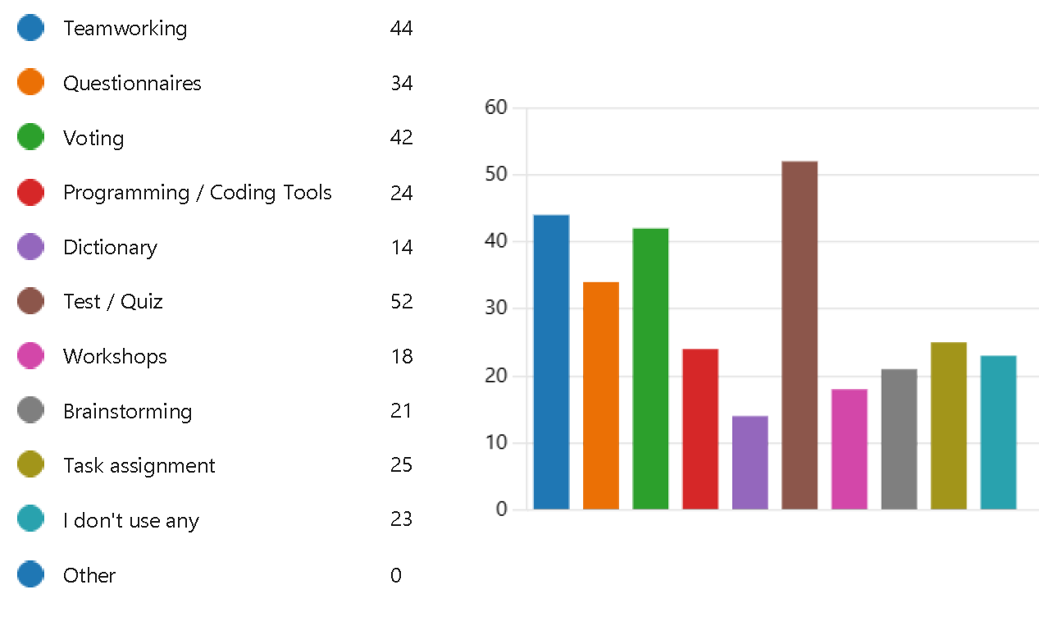

**Figure 27** – Other functionalities used by teachers

Teachers use mostly **test/quiz, teamworking, voting** and questionnaires.

**27. Here, you may put other functionality that you are missing**

This question allows you to enter a free response. Respondents answered among others: selective publication of course contents, better integration with conferencing/video handling, notebook drawing and audio synchronized, programming/coding tools, scheduled publishing all sorts of course contents, specifical tool for booking/organization of students reception for explanations, clarifications, tutoring, tracking students engagement, double blind review, useful plug-ins to research devices.

**28. What makes it difficult for you to work with ICT tools?**

Another open-ended question in which answers were obtained, among others: always having to start from scratch, as students rarely demonstrate an adequate level of ICT literacy, checking the validation of information, complicated forms of programs usually, cross connection with other apps (DISCORD, TELEGRAM, ...), ICT were very useful during Corona time. Hovewer, now we use less ICT tools. The students don't complain about it, instructions are usually too long and complicated, lack of more sophisticated tutorials, which explain features of the ICT tools in practical usage. A lot of them show only basic activities, lack of written documentation; low quality of user documentation, most tools are not adapted, Nic. Enostavno je. Nimam vedno na voljo interneta, Not adapted to my specific needs, Poor cooperation with colleagues, Poznavanje programov in zadostna moč pc. Slow (MS Teams), missing functionality, software (web browser) compatibility with the material, broadband vs file size, and lack of tutorials for all functionalities, Students cheating on online exams, copy-pasting from web for homework. There are too many of them on market, They work inconsistently, and many departments have their own, time consuming, user manuals for free tools (moodle) suck or not existing. too many tools, which i dont know what are meaning.

**29. What kinds and types of resources you can share through the ICT tool you use?**

Teachers mainly share: PDF, URL, PPT, ZIP, folders and CAD/CAM

**30. Additional comments:**

ICT tools can probably be used in a more efficient way to support the teaching and learning process, in the previous question (29). I can share everything, but that does not mean that I do...CAD/CAM in previous questuíon is interpreted as CAD/CAM model files, not the systems as such. Q 14 and 15 don't have answer "none". ICT tools are grat to use

thank you for your work and i wish you a successful project, I am using live classroom and lab teaching with direct interaction with students as much as possible. I also broadcast lectures over Zoom and use Canvas mainly for documentation, assignments and group division. I use moodle which is a great tool but lacks integration with other platforms and it looks kind of obsolete and UX is really not great, ICT tools need to be used with care. In my opinion, it is either traditional teaching/examination, or self-paced MOOCs. I do not have any, Virtual classroom makes my studying more organised. I think the structure and first view impression of ICT tool containment is pretty important. I'm Giuseppe Fiorentino and I'm willing to help and collaborate on the project. For engineers cad option. Online studying is not the future. Predolga anketa. Raje imam knjigo kot to. Have a nice day. Pogrešam učenje bolj na praktičen način na realnih primerih. It is important that all types of files are integrated and easily shared on the platform. The tool has to also have a search/timeline for finding older files. . Good for long distances. Veri najs. This survey is confusing. Nice. All good. Faster and not so unneccesarily packed user interfaces.

## Student questionnaire results

The student survey contains 22 questions. The following is the content of the questions and the responses of the survey respondents. with comments.

**1. University**

A total of **229 students** mainly from universities - partners of the TET project - participated in the survey, as shown in Figure 1.

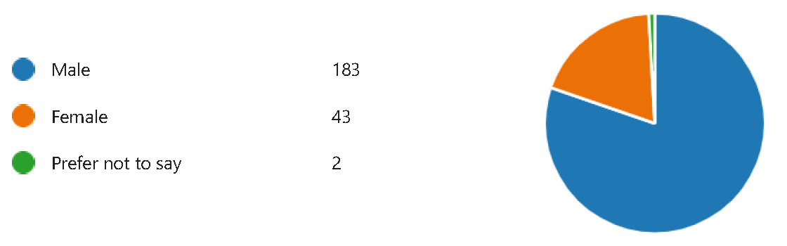**2. Gender**

**Figure 28** – Gender of respondents

The majority of respondents were declared male gender.

1. **Level of study**

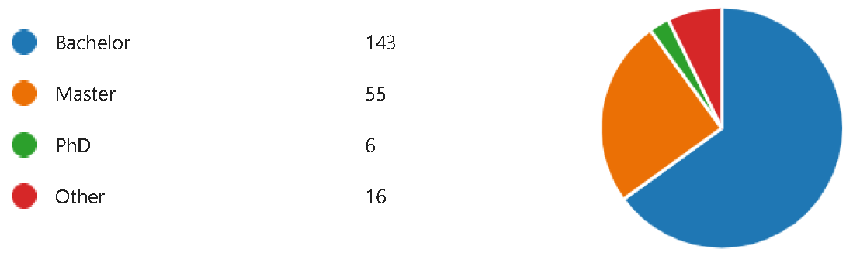

**Figure 29** – Level of study

Około 60% respondentów studiuje na poziomie bechelor, 24% na poziomie master.

**4. What e-learning platforms / tools do you use?**

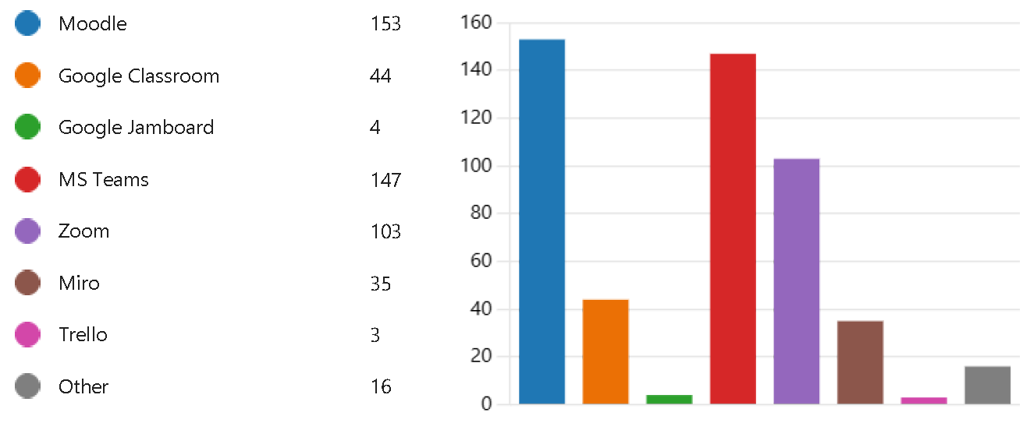

**Figure 30** – E-learning platforms used by students

Students mostly use **Moodle, MS Teams and Zoom** in distance learning.

**5. What tools supporting e-learning do you use in teaching / learning process?**

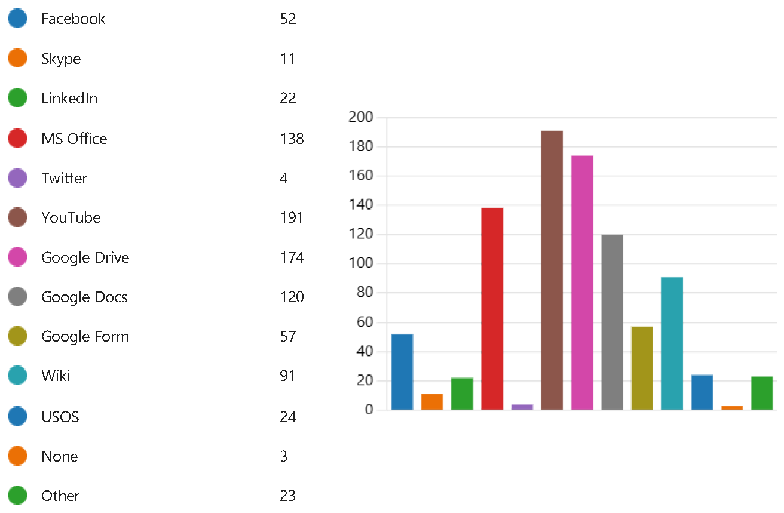

**Figure 31** – Tools supporting e-learning used by students

In addition to the e-learning platforms mentioned in question 4, students use many tools to support e-learning. Among the most popular are: **YouTube, Google Drive and MS Office**. Students also use Google Docs, Wiki, Facebook, Google Form.

**6. What creation functionalities do you use in the e-learning platforms / tools you use?**

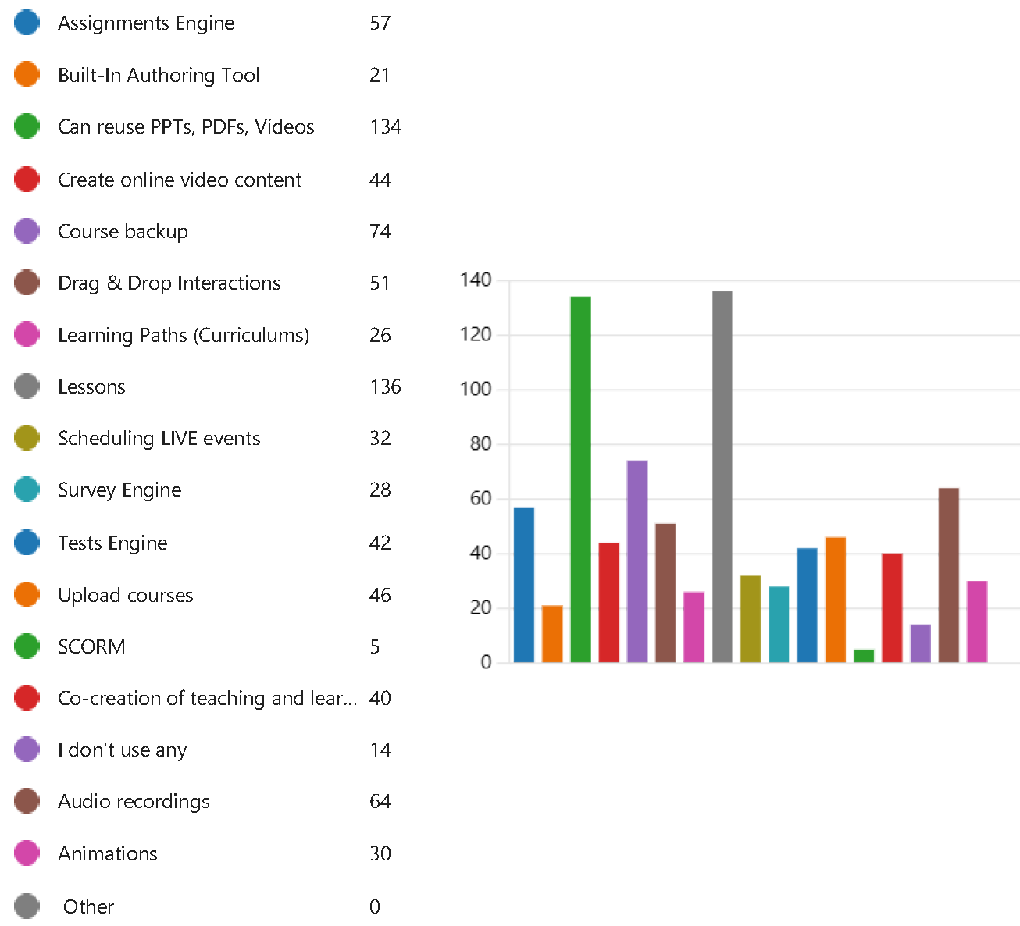

**Figure 32** – Creation functionalities used by students

Students mostly use the ability to **reuse materials (PPT, PDF, Video), lessons, course backup,** audio recording, drag & drop interactions, assignments engine, create video content, test and survey engine, audio recordings. SCORM format seems to be less important.

**7. What creation functionalities do you miss in the e-learning platforms / tools you use?**

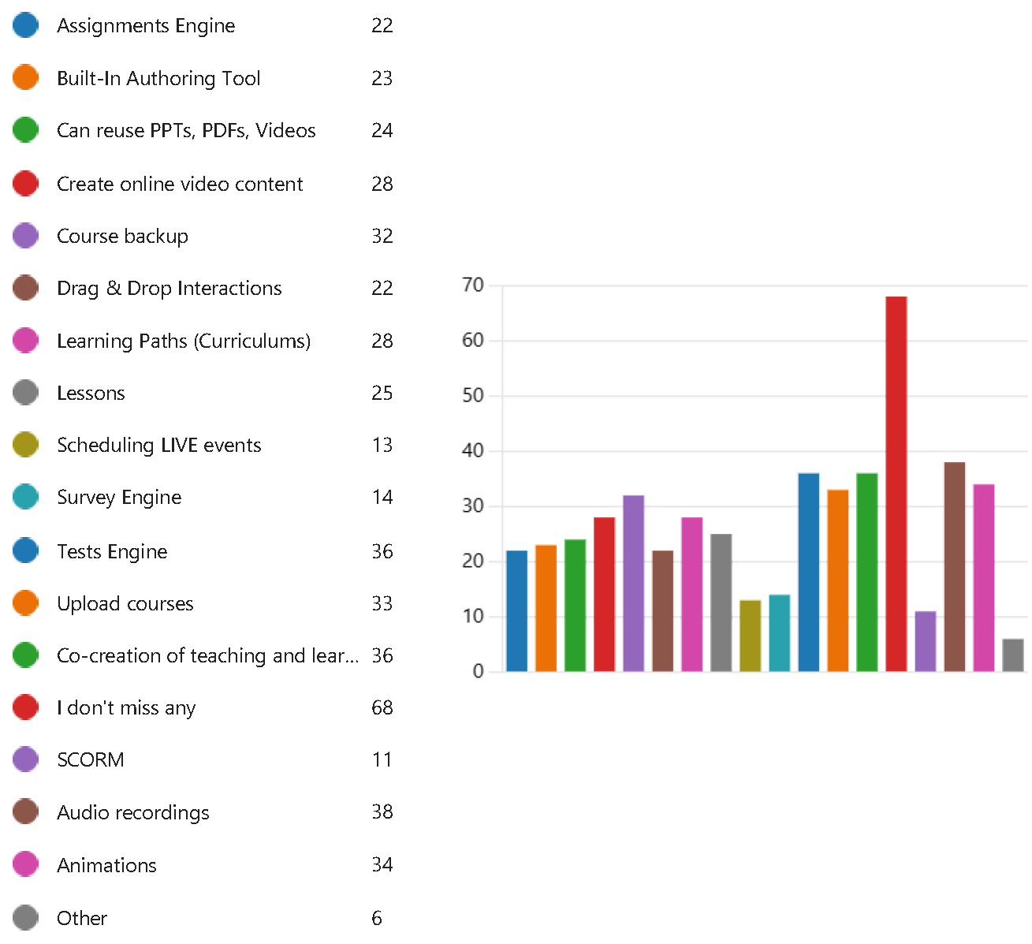

**Figure 33** – Creation functionalities missed by students

Students most often lack functionality **audio recordings, co-creation of teaching and learning, test engine**, animations, upload courses, course backup.

**8. What are the useful co-creation functionalities of the e-learning platforms / tools you use?**

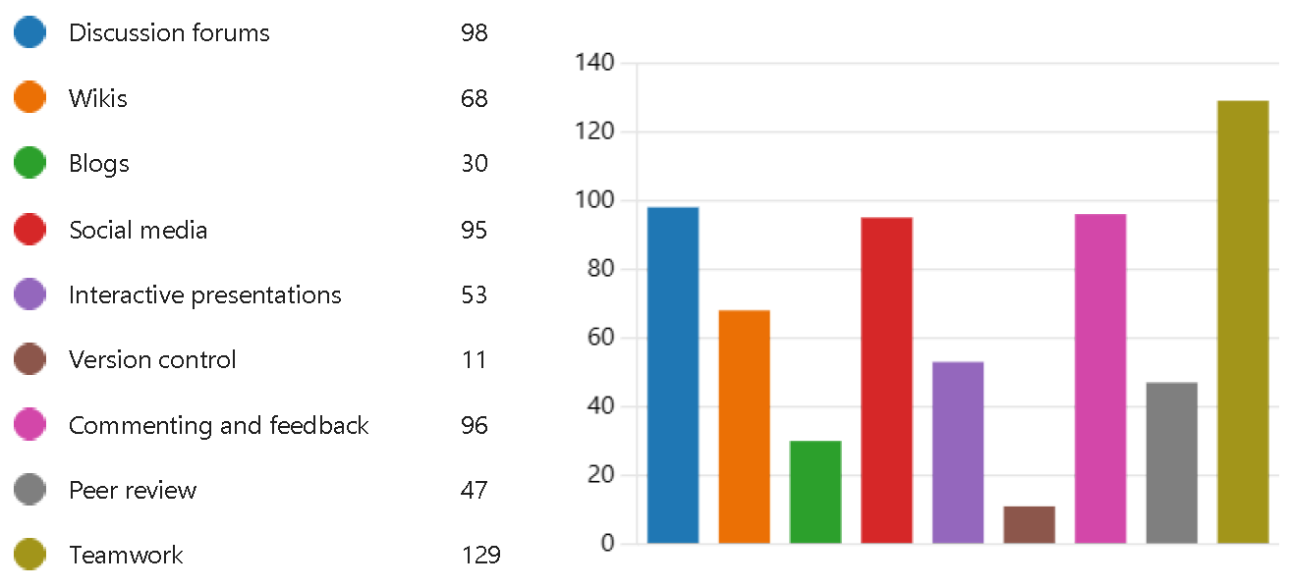

**Figure 34** – Co-creation functionalities used by students

Students mostly use **teamworking, discussion forums, commenting and feedback**, social media, wikis, interactive presentations and peer review.

**9. What co-creation functionalities do you miss in the e-learning platforms/tools you use?**

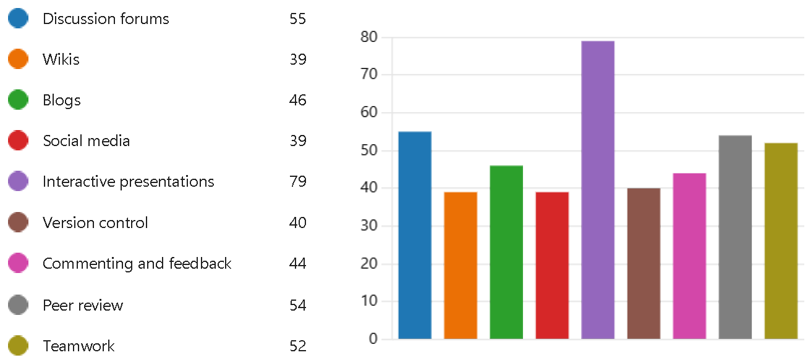

**Figure 35** – Co-creation functionalities missed by students

Students in the co-creation of materials would like to use: **interactive presentations, discussion forums, peer review**, social media and blogs.

**10. What are the useful communication functionalities of the e-learning platforms / tools you use?**

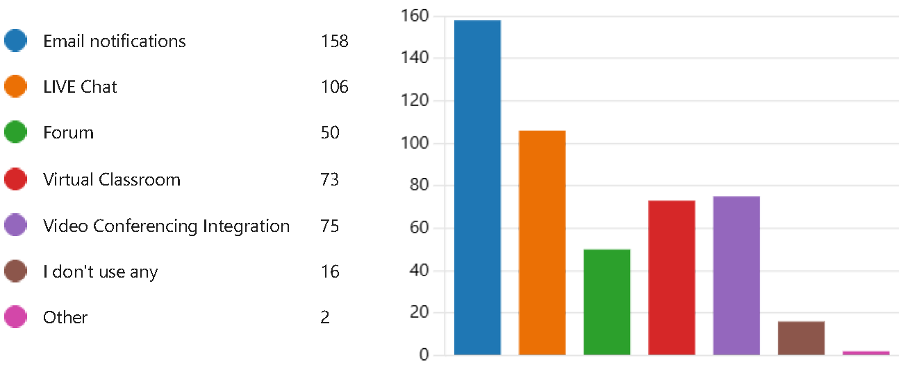

**Figure 36** – Communication functionalities used by students

For students the most usefull communication functionalities are: **email, chat, video conferencing**, virtual classroom and forum.

**11. What communication functionalities do you miss in the e-learning platforms / tools you use?**

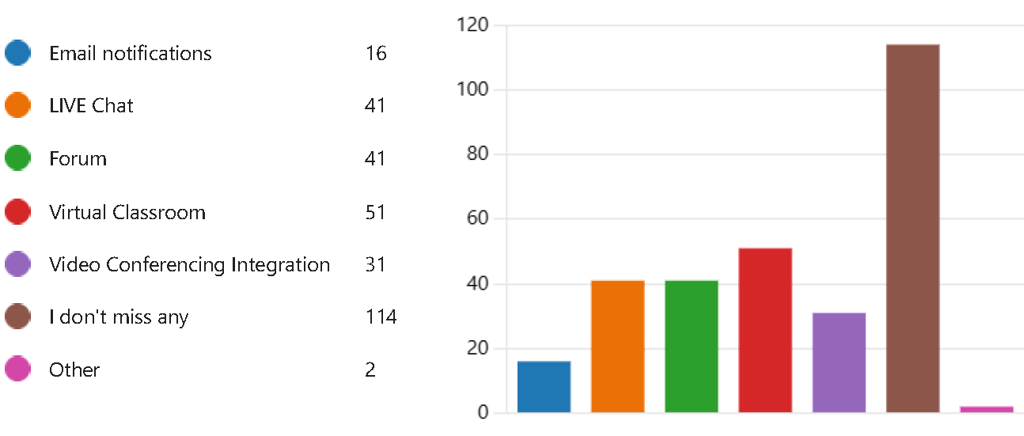

**Figure 37** – Communication functionalities missed by students

More than half of the students do not feel a lack of communication tools. The others mainly point to the lack of **virtual classroom, forum and live chat**.

**12. What are the useful gamification functionalities of the e-learning platforms / tools you use?**

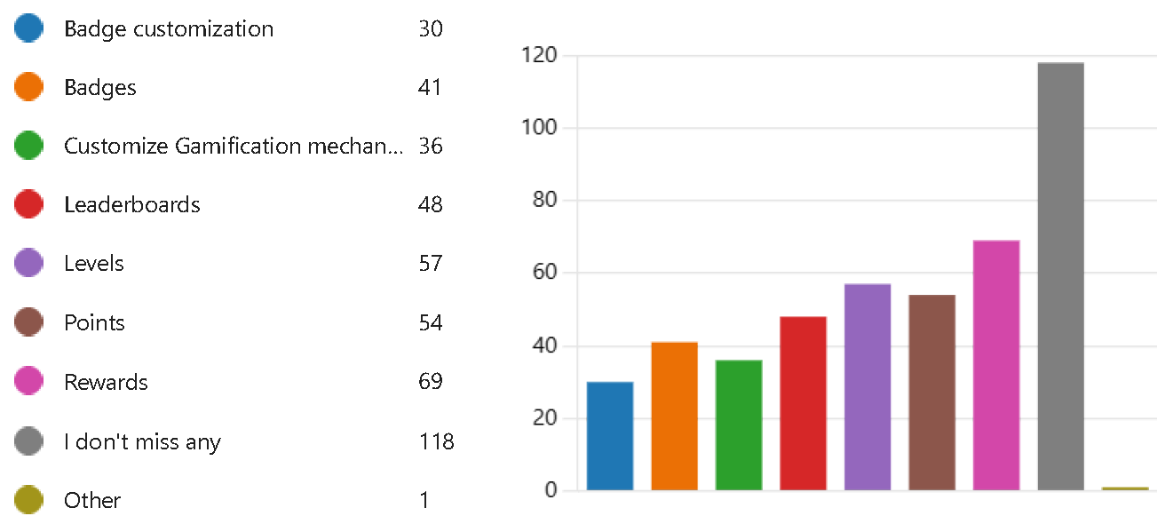

**Figure 38** – Gamification functionalities used by students

Most students do not use gamification. The others use **rewards, levels, points** and leaderboards.

**13. What gamification functionalities do you miss in the e-learning platforms / tools you use?**



**Figure 39** – Gamification functionalities missed by students

Most students see no need for gamification. The others would mainly like to benefit from: **rewards, levels** and **points**, badges and leaderboards.

**14. What are the useful learning types functionalities of the e-learning platforms / tools you use?**

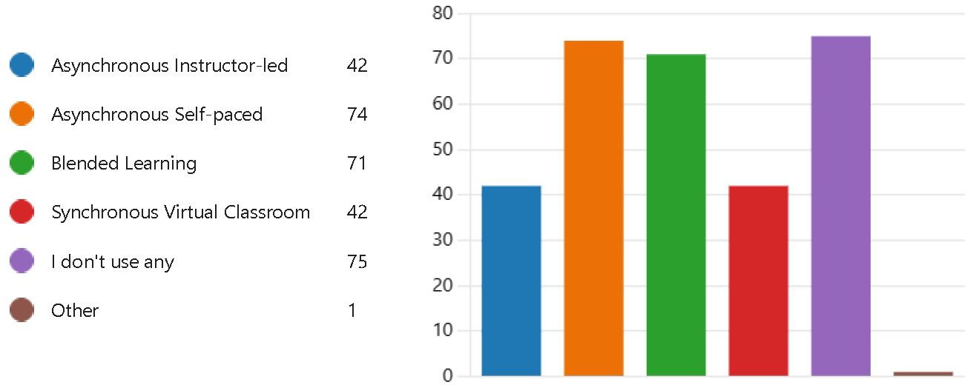

**Figure 40** – Learning types used by students

Students use mostly **asynchronous self paced and blended learning**.

**15. What learning types functionalities do you miss in the e-learning platforms / tools you use?**

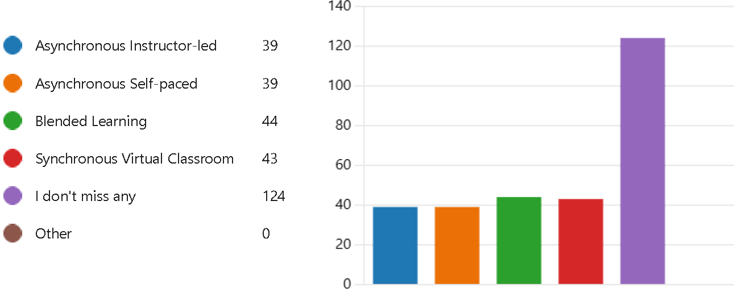

**Figure 41** – Learning types missed by students

Most students do not feel there is a lack of one of the indicated types of e-learning. Among the remaining responses, **blended learning** stands out slightly..

**16. What are the useful mobile learning functionalities of the e-learning platforms / tools you use?**

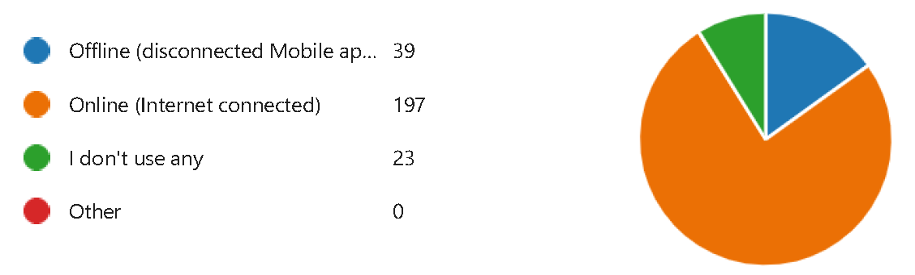

**Figure 42** – Mobile learning functionalities used by students

Students use mostly online mobile learning.

**17. What mobile learning functionalities do you miss in the e-learning platforms / tools you use?**

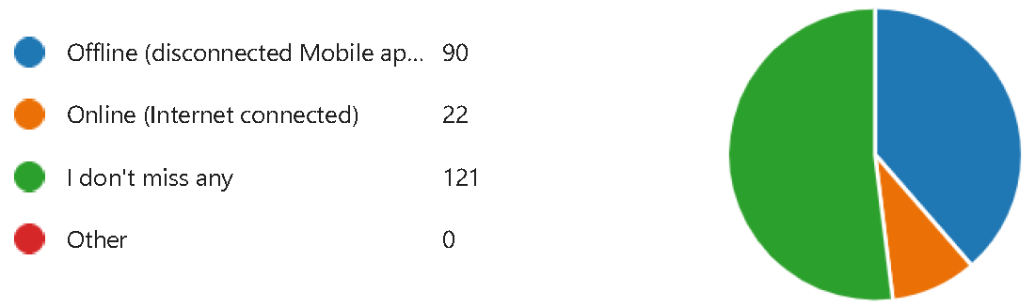

**Figure 43** – Mobile learning functionalities missed by students

Students mostly miss offline learning

**18. What other useful functionalities of the e-learning platforms / tools you use?**

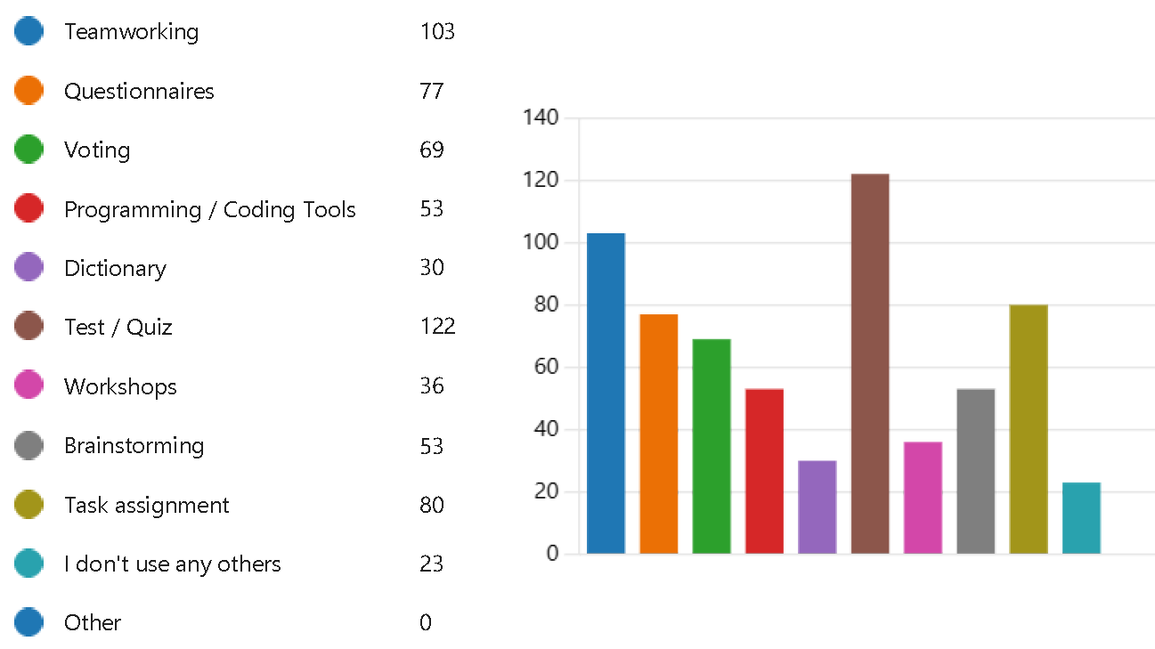

**Figure 44** – Other functionalities used by students

Some of the most popular other tools include**: test/quiz, teamworking, task assignment**, questionnaires and voting.

**19. Here, you may put other functionality that you are missing**

This question allows you to enter a free response. Respondents answered among others: Barra di ricerca all'interno del corso per cercare i vari file caricati ,Being able to make a groupchat (like whatsapp, messenger or discord and integrating it easily with the platform itself). I think it's an easier way to connect but also for group related work,Corso di excel e Word avanzato con riconoscimento ( sia per studenti e sia per insegnanti) , integrandolo ulteriormente con le materie, I think that we could use the platform for teamwork, since now we haven’t use the platform at full potential, Merge pdf,More efficient communication with teachers, Old testes and exams, Online games for beetween lectures, Task assignaments, questionnaires, exam paper and simulation, Teamworking and communicating with other students, Teamworking and workshops, Video calling integration into canvas.

**20. What makes it difficult for you to work with ICT tools?**

Another open-ended question in which answers were obtained: Always need good network connection. Bad connection. Bad GUI. Clumsy interfaces, bad layout, app differs from website. Don’t know the real power of the platform. Each prof use a differenti program and that cause a lot of caso because when I search files where I can study, they are spread in too much platforms. It is usually easy for me. Difficult might be on the spread of many different tools that requires everyone to have many tools installed and sometimes one does not know how to use one of them. It's difficult to do team work through ICT because everyone are from different backgrounds and fields sometimes, and each and everyone have their personal opinion. Keep up on new tools and use all its functionalities properly for your purposes. Lack of face-to-face contact. Lack of free time. Lagging problems, problems during videocall and "heavy" softwares. Most often bad synchronisation between two people writing in the same document (word). New user interface for each different ICT. Not having a stable or fast internet connection can hinder learning. Too many tools can create confusion on the students. Nothing is particularly difficult; there are some functionalities (for which I'm unsure whether they are baked into the system or preferred by the professors), like timed homeworks? It just stresses me out...Poor internet quality. In my opinion, live meetings are better when it comes to the effect. Problemi with log in into moodle and teams, the impossibility of download to use offline. Screen resolution. Slow internet. Sometimes (hardly ever) I get confused by some notifications. The access at the platform sometimes requires much time. The comunity and all the password request. The crapy design and unreliability. They are mostly intuitive. They crash easily when 200 students are online. Too many different ICT tools available. Especially for group work the first meeting is only to decide which ICT is used. Too many different programmes. It should be one for the majority. [Discord and Youtube are best in this regard].

**21. What kinds and types of resources you can share through the ICT tool you use?**

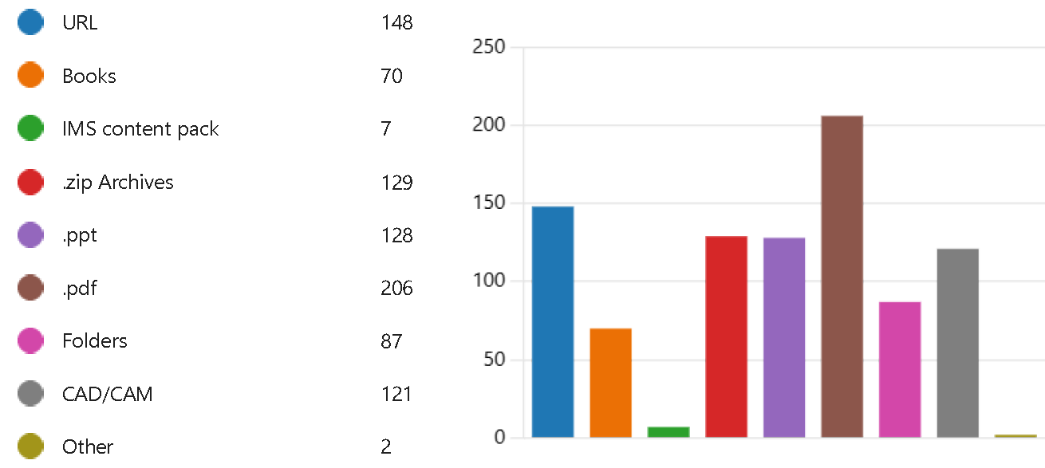

Students share mostly PDF, URL, ZIP, PPT. and CAD/CAM.

**22. Additional comments:**

An common information platform includes every resource from different universities and research institutions along with a simplified versions. An easy and fun quiz. Regards. Did not use much of e learning platforms in masters so have very less idea about it. Generally it works good. Good quiz! I am not entirely sure I got every question entirely correct. I am satisfied with the applications I am able to use for e-learning. I am satisfied with the current system. I feel that the e-learning platforms present in the market currently are quite versatile and have great functionality and try to cover everything. However, I have noticed that there is uniformity between these platforms. As in that some platforms offer certain services which are easier to use than others so I feel the ease of using a platform is also an important factor to be considered

I have no additional comments. I think ICT tools are perfect for sharing material, ideas, comments, lecture recording and whatever else, but I still strongly prefer to have at least the lecture in a physical format, because for me online lectures are not useful and difficult to follow. I think that the most effective way to learn is by doing assigments that are given to you. I wish ICT were better integrated in the learning process but not to the point where they overshadow the individual, in-person approach (e.g.: replacing a live discussion with a zoom conference, a class with a video or practical work with filmed examples of experiments...). I would like blended lessons. I would like to have team where students work together to solve technological problems like creating process, mechanical components, impiants ...I would love to see more interactic online couses. Interactive tools. It would be nice if there were more self-paced offline courses . KTH should update his IT tools. More live registrations. More online class. più integrazione nei sistemi. some forums for my field of study do exist but in my opinion a forum where there would be more active students and also professors would be very beneficial. Sviluppare piattaforme che integrano modalità miste e prevedono spazi appositi dove caricare materiale ai fini di esercitarsi all'esame(con soluzioni). Teamworking, Workshops and Brainstorming could be useful functionalities. The colors are horible. The design of the system depends on the end utility. Skill-based courses on E-learning platforms for different target audiences where gamification is irrelevant. However, Duolingo's model (gamification) seems like an attention-captivating feature for extracurricular learning such as learning a language. There are so many resources that need to be addressed to help students. So creating a platform where every student can access the unknown resources will be a great gesture for improving their knowledge and experience. we mostly use open source, which I support, but the university then mostly just ignores all the problems. While I enjoy using online tools, there is not quiet enough projects i can use them on.

# Summary

The survey conducted allows us to make recommendations on the functionality of the designed The Evolving Textbook (TET).

The TET based on the collective work of teachers and students should provide a good communication environment for its users. In the consensus opinion of teachers and students, the two primary tools in this regard are email and chat. Additional suggested communication platforms could be virtual classroom, video conferencing and forum. The creation of teaching materials requires tools that support the input, editing and formatting of content. Functionalities useful in this area indicated by survey respondents primarily include: the ability to reuse materials, drag&drop, backup, lesson creation and test engine.

Survey respondents also indicate the importance of supporting co-creation of teaching content. In the area of co-creation, support for teamworking, commenting and feedback, and discussion forums were primarily indicated. In addition, respondents expect support for creating interactive presentations and peer review.

Teachers should also be provided with opportunities to organize and evaluate student work. Teachers indicated adding users, self-registration, browsing list of users, user login page, and role assignment as useful administrative functions.

To evaluate student work, teachers mainly use attendance/activity tracking, gradebook and grade comments. Additionally, the desire to use multiple grading scales was indicated.

Additionally, effective TET development can be supported by gamification. Teachers and students agree on the main functions that allow the assignment of points, rewards and levels.

# References

............................

# Appendixes



**Lead Partner**

**Partners**

